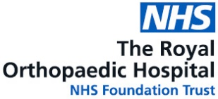

31/62

31/62

URGENT 2 WEEK WAIT REFERRAL FOR SUSPECTED BONE CANCER AND SUSPECTED SOFT TISSUE SARCOMA

These forms should only be used for suspected cancer and in conjunction with the NICE Referral Guidelines for suspected Cancer referral and Recognition June 2015
https://www.nice.org.uk/guidance/ng12/chapter/1-Recommendations-organised-by-site-of-cancer
For suspected sarcoma of the Head and Neck, Breast or Intra-abdominal regions, please refer to the Queen Elizabeth Hospital Birmingham. Please see website https://www.uhb.nhs.uk/gp-referral-forms.htm

On full completion of this form, please email to ROHOncology.referrals@nhs.net
Please note incomplete referrals will not be accepted. Please also include a copy of the GP Summary Record
Patient Details  Name  Date of Birth  Age  Gender  Address  Telephone Number  Mobile Number  NHS Number  Interpreter Required Y/N  Main Language |  | GP Details  Practice Name  Practice Address  Telephone  Contact Email  Date of Decision to Refer  Date of Referral  Referring GP
Suspected Soft Tissue Sarcoma  Suspected Bone Sarcoma  Site: | Imaging performed (Tick all relevant)  X-RAY Bone Scan Ultrasound MRI CT PET  Other (please state)  Where was the imaging performed?
Please ensure all relevant imaging is sent with this referral, along with the report. Failure to do so will delay the patient’s pathway.

GP Summary Care Record Required - medical history, examination, allergy, medications)

