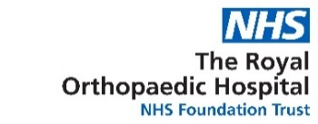
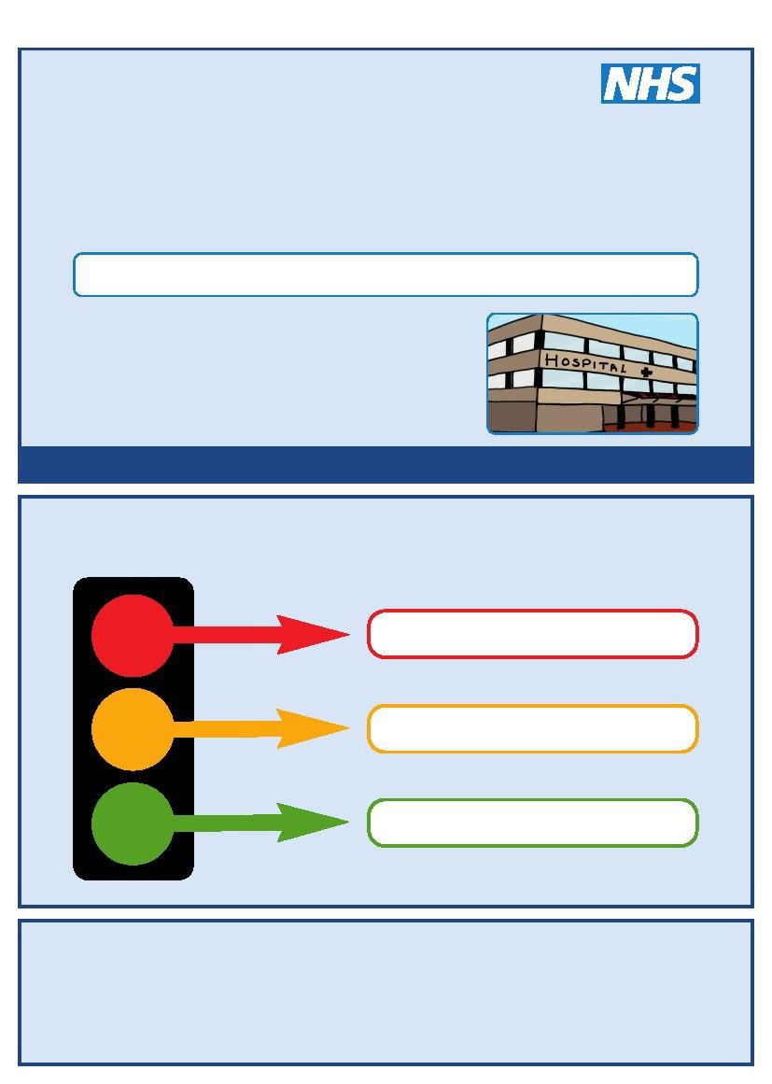
This is my
My Details
Hospital Passport
For people with learning disabilities coming into hospital
My name is:
I like to be called:

If I have to go to hospital this book needs to go with me, it gives hospital staff important information about me.

It needs to hang on the end of my bed and a copy should be put in my notes.

This passport belongs to me. Please return it when I am discharged.

Nursing and medical staff please look at my passport before you do any interventions with me.

Things you must know about me

Things that are important to me

My likes and dislikes

Mental Capacity Act 2005
If I am assessed as lacking the capacity to consent to my treatment the following people must be involved in best interest’s decision making
Name Relationship Contact Details
Name Relationship Contact Details
Name Relationship Contact Details
Name Relationship Contact Details

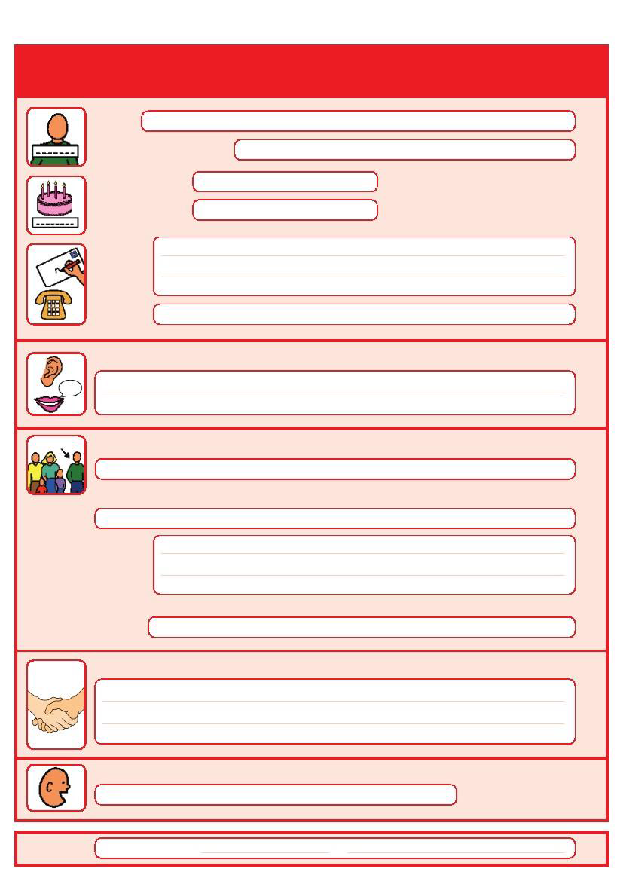
Things you must know about me

Name:

Likes to be known as:

NHS number: Date of Birth:

Address:

Tel No:

How I communicate – e.g. What language I speak / Equipment / Signs / Photos / Symbols I use:

Family contact person, carer or other support:

Relationship e.g. Mum, Dad, Home Manager, Support Worker:

Address:

Tel No:

My support needs and who gives me the most support:

My carer speaks:

Date completed by 1

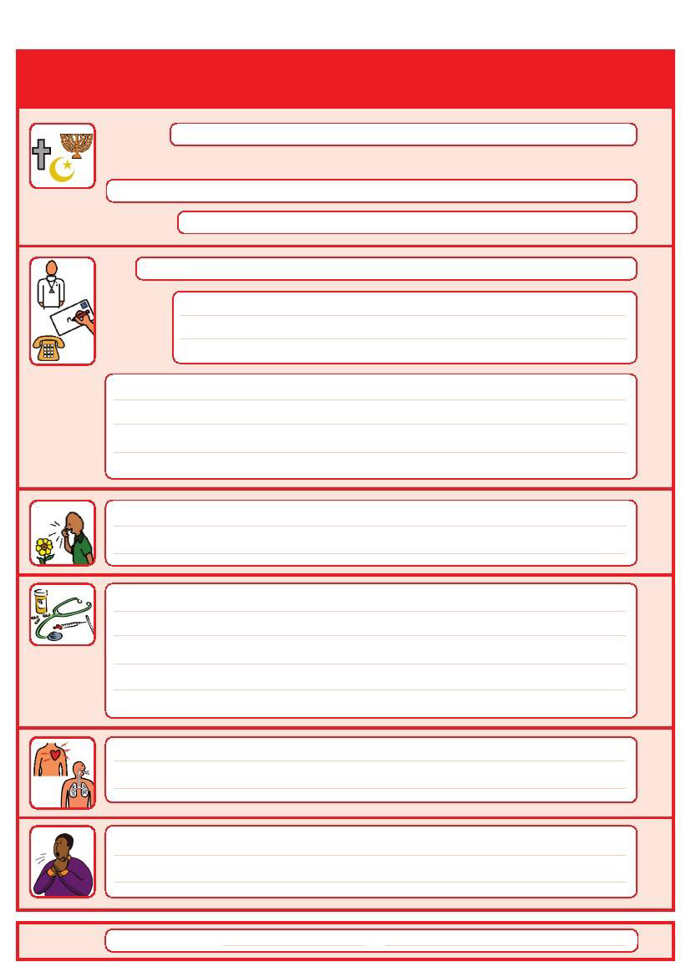
Things you must know about me

Religion: Religious/Spiritual needs:

Ethnicity:

GP:

Address:

Tel No:

Other services/professionals involved with me:

Allergies:

Medical Interventions – how to take my blood, give injections, BP etc.

Heart

Breathing problems:

Risk of choking, Dysphagia (eating, drinking and swallowing):

Date completed by 2

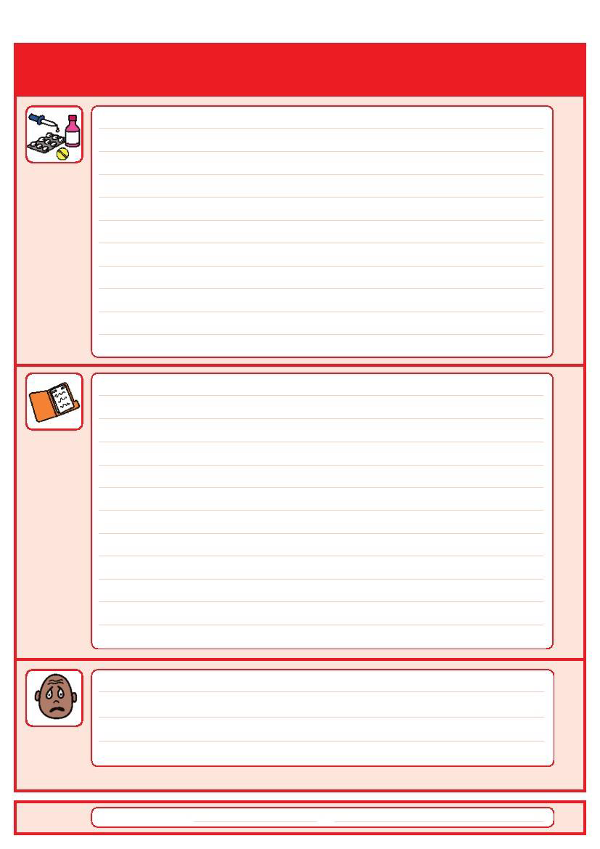
Things you must know about me

Current medication:

My medical history and treatment plan:

Operations and illnesses I have had:

What to do if I am anxious, worried or upset:

Date completed by 3

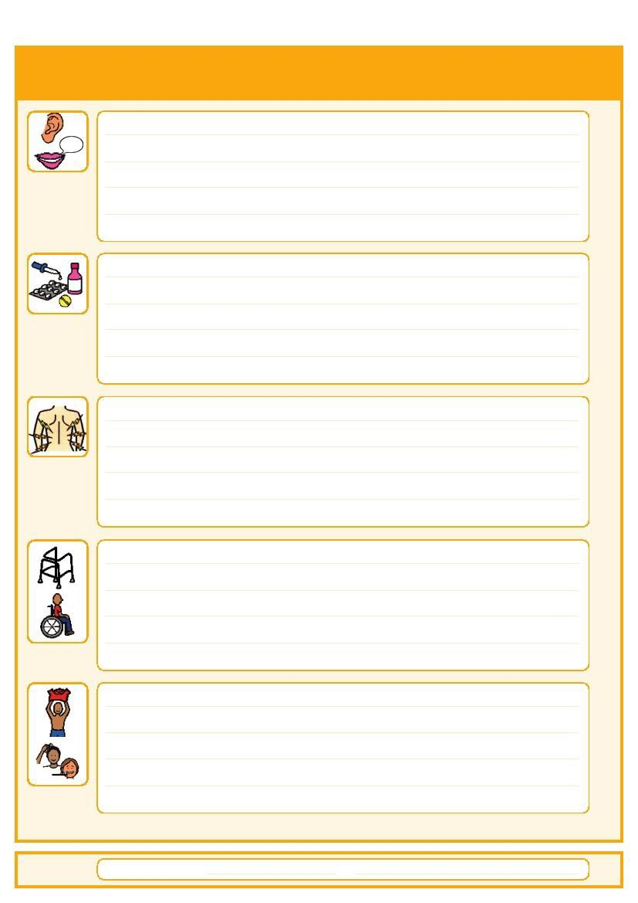
Things that are important to me

How to communicate with me (such as speed of speaking, signing, pictures, photos, symbols):

How I take medication: (whole tablets, crushed tablets, injections, syrup)

How you know I am in pain:

Moving around: (Posture in bed, walking aids)

Personal care: (Dressing, washing, brushing teeth,)

Date completed by 4

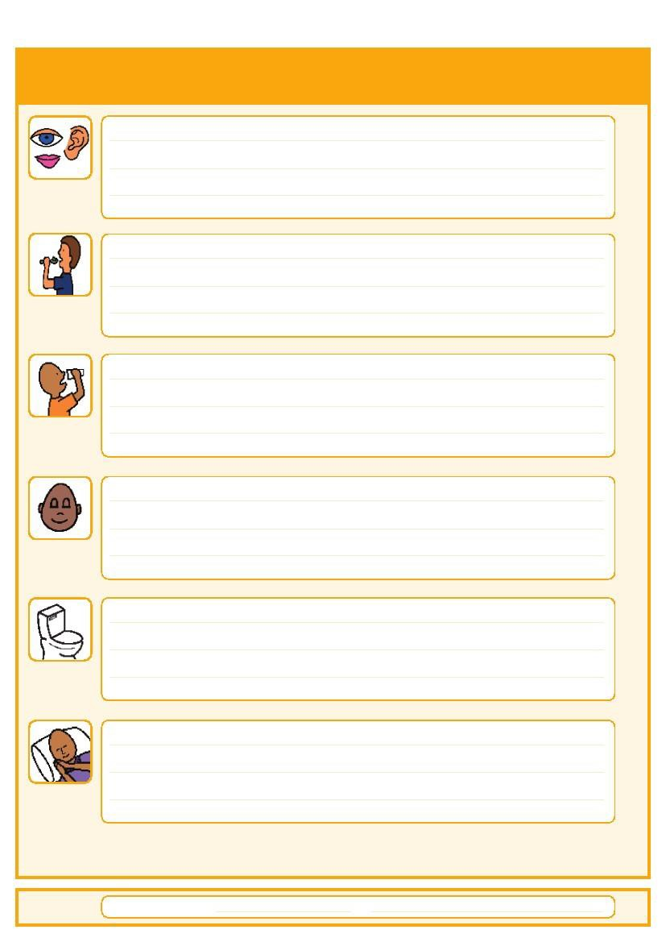
Things that are important to me

Seeing/Hearing/ smelling: (Problems with sight, smell or hearing)

How I eat: (Food cut up, pureed, risk of choking, help with eating)

How I drink: (Drink small amounts, thickened fluids)

How I keep safe: (Bed rails, support with challenging behaviour)

How I use the toilet: (Continence aids, help to get to toilet)

Sleeping: (Sleep pattern/routine)

Date completed by 5

My likes and dislikes

Likes: for example - what makes me happy, things I like to do e.g. watching TV, reading, music, routines.

Dislikes: for example - don’t shout, food I don’t like, physical touch, loud noises, bright lights.

Things I like
Please do this:
Things I don’t like
Don’t do this:

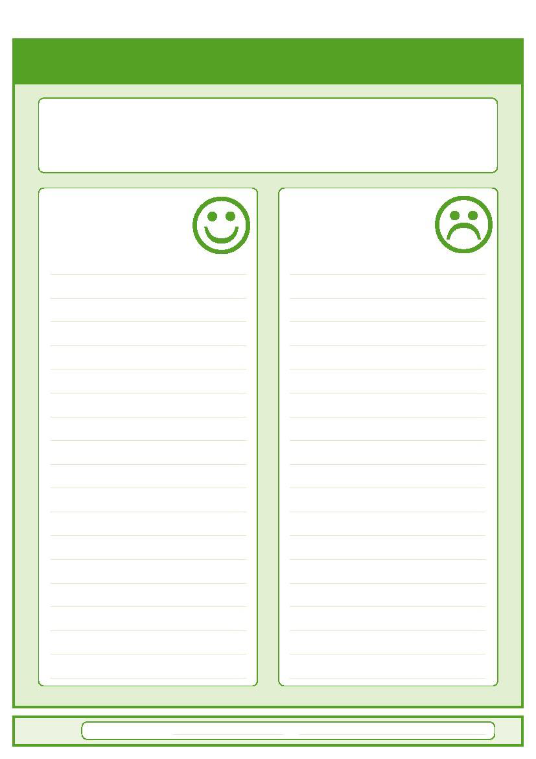

Date completed
by
6

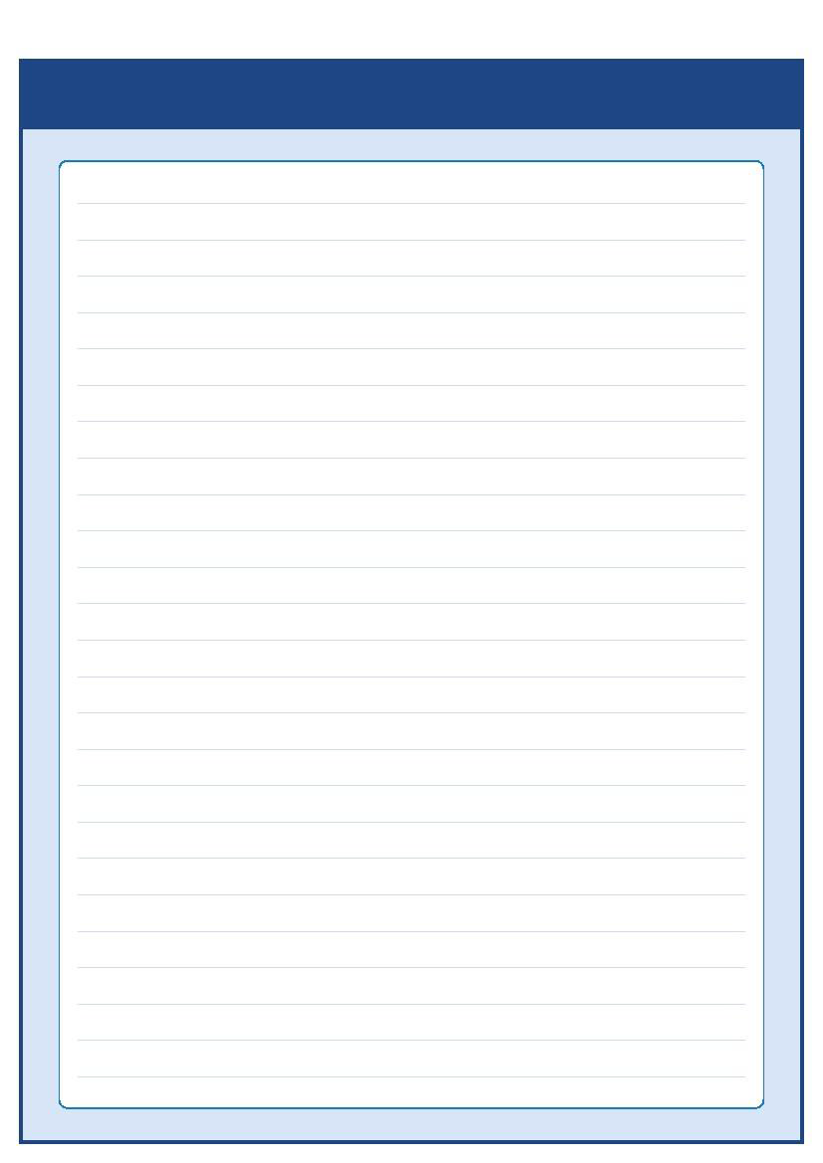
Notes, Annual Health Checks & Websites

Information and useful websites
Useful websites:

- Accessible health information - www.easyhealth.org.uk

- Advice and support – www.mencap.org.uk/advice-and-support
- Annual health checks - www.england.nhs.uk/learning-disabilities/improving-health/annual-health-checks/
Anyone over the age of 14 with a learning disability should have an annual health check with their GP. Speak to your GP to arrange your annual health check.

- Books beyond words - www.booksbeyondwords.co.uk

- British Institute of Learning Disabilities – www.bild.org.uk

Please contact your GP or local community learning disability team if you have any questions about the passport

This Hospital Passport was adapted by Great Ormond Street Hospital for Children Foundation NHS Trust from the South West London Access to Acute Group which was on original work by Gloucester Partnership NHS Trust. This hospital passport has been further adapted for use locally by the Royal Orthopaedic Hospital NHS Trust.

AS.42a (12.09)

7

